**Nguyễn Mạnh Bảo Tín MSSV SE170134**

**[tinnmbse170134@fpt.edu.vn](mailto:tinnmbse170134@fpt.edu.vn)**

**Subject: PRF192- PFC**

**Workshop 05**

**Objectives: Use functions in the library math.h for getting an integer at random and stdio.h for formatting output**

**Grading: 4 problem, marks: 2, 2, 3, 3**

**Problem 1. Dice Throws ( 2 marks)**

You are required to develop a program that will throw two dice until the top faces of the two dice total to a specified number.

The output from your program looks something like:

|  |
| --- |
| Dice Thrower  ============  Total sought : 11  Result of throw 1 : 1 + 3  Result of throw 2 : 4 + 4  Result of throw 3 : 6 + 2  Result of throw 4 : 5 + 6  You got your total in 4 throws! |

Algorithm should be as the following

/* Get a random integer between min and max randomly */

**int intRandom(int min, int max)**

{ /* Refer to the lecture to get algorithm for this task */

}

**main()**

Variable : int total, x,y, count

do

{ Accept total;

}

while (total<2 || total >12);

count =1;

do

{ x= intRandom(2,6);

y= intRandom(2,6);

Print out (“Result of throw %d “ %d + %d\n”, count, x, y)

count++;

}

while (x+y != total);

**Program 1.**

#include <stdio.h>

#include <stdlib.h>

#include <math.h>

int intRandom( int min_num, int max_num);

int main()

{

int total;

int count, x, y;

do

{

printf("Accept num: ");

scanf("%d", &total);

}

while (total <2 || total >12);

count=1;

srand((unsigned int)time(NULL));

do

{

x=intRandom(2,6);

y=intRandom(2,6);

printf("Result of throw %d: %d + %d\n", count, x, y);

count++;

}

while (x+y!=total);

printf("You got your total %d throws!", count-1);

}

intRandom(int min_num, int max_num)

{

int a, b;

do

{

a= rand()%10;

}

while (a<min_num || a>max_num);

return a;

do

{

b=rand()%10;

}

while (b<min_num || b>max_num);

return b;}

**Screenshot:**

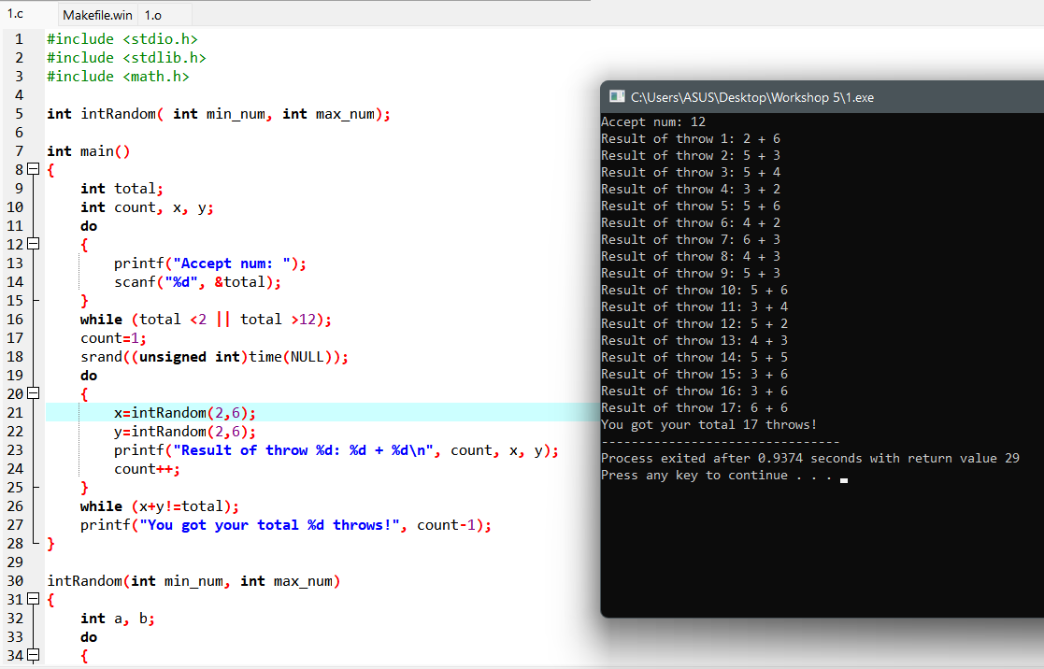

**Problem 2. Ball Lottery ( 2 marks)**

A basket contains ten balls.

Balls are numbered from 1 to 10.

User gets a pair of balls and he/she hopes that sum of numbers is equal to a known expected total.

This problem is the same with the previous problem but the total is between 2 to 20.

The output from your program looks something like:

|  |
| --- |
| Ball Lottery  ============  Total sought : 11  Result of picks 1 and 2 : 1 + 3  Result of picks 3 and 4 : 4 + 5  Result of picks 5 and 6 : 6 + 3  Result of picks 7 and 8 : 5 + 6  You got your total in 8 picks!  The algorithm for this program is similar to those in the previous problem |

**Program 2.**

#include <stdio.h>

#include <stdlib.h>

#include <math.h>

int intRandom( int min_num, int max_num);

int main()

{

int total;

int count, x, y;

do

{

printf("Ball Lottery\n");

printf("============\n");

printf("Total sought: ");

scanf("%d", &total);

}

while (total <2 || total >20);

count=1;

srand((unsigned int)time(NULL));

do

{

x=intRandom(1,10);

y=intRandom(1,10);

printf("Result of pick %d: %d + %d\n", count, x, y);

count++;

}

while (x+y!=total);

printf("You got your total in %d picks!", count-1);

}

intRandom(int min_num, int max_num)

{

int a, b;

do

{

a= rand()%10;

}

while (a<min_num || a>max_num);

return a;

do

{

b=rand()%10;

}

while (b<min_num || b>max_num);

return b;

}

**Screenshot:**

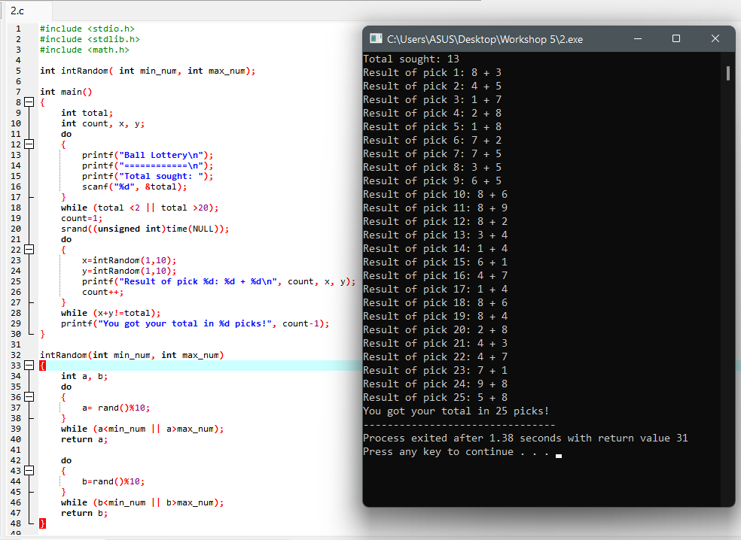

**Problem 3. Program using menu ( 3 marks)**

Write a C program using the following simple menu:

1- Processing date data

2- Character data

3- Quit

Choose an operation:

* When user chooses 1: User will enter values of date, month, year then the program will announce whether this date is valid or not.
* -When user chooses 2: User will enter two characters, then the program will print out ASCII codes of characters between them using descending order. Examples: Input: ca

Output:

c: 99, 63h

b: 98, 62h

a: 97, 61h

**Program 3:**

#include <stdio.h>

#include <windows.h>

#define maxChoice '3'

char getUserChoice()

{

char n;

printf("1-Processing date data\n");

printf("2-Character data\n");

printf("3-Quit\n");

printf("Choice [1..3] : ");

fflush(stdin);

scanf("%c", &n);

return n;

}

void function3()

{

printf("Program exiting...");

}

int validDate( int d, int m, int y)

{

int maxd = 31;

if ( d < 1 || d > 31 || m < 1 || m > 12 || y < 1)

return 0;

if ( m == 4 || m == 6 || m == 9 || m == 11) maxd = 30;

else if (m == 2)

{

maxd = ( y % 400 == 0 || ( y % 4 == 0 && y % 100 != 0) )? 29:28;

}

return d <= maxd;

}

void function1()

{

int d, m, y;

printf("Input day, month, year: ");

scanf("%d, %d, %d", &d, &m, &y);

if ( !validDate( d, m, y) ) printf("Invalid date.");

else printf("Valid date.");

printf("\n");

system("pause");

system("cls");

}

void function2()

{

char c1, c2;

int c;

printf("Input 2 character (c1, c2): ");

fflush(stdin);

scanf("%c, %c", &c1, &c2);

if (c1 < c2) c1 ^= c2 ^= c1 ^= c2;

for (c = c1; c >= c2; c--)

printf("%c : %3d %3Xh\n", c, c, c);

printf("\n");

system("pause");

system("cls");

}

int main()

{

char userChoice;

do

{

userChoice = getUserChoice();

switch(userChoice)

{

case '1':function1();break;

case '2':function2();break;

case '3':function3();break;

default : printf("Please only choose between 1 or 2 or 3.\n\n");

}

} while (userChoice != maxChoice);

}

**Screenshots:**

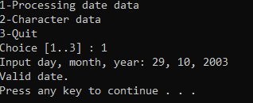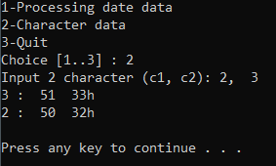

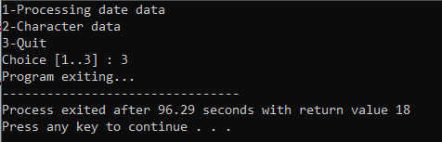

**Problem 4. Program using menu ( 3 marks)**

Write a C program using the following simple menu:

1- Quadratic equation ( phương trình bậc 2)

2- Bank deposit problem

3- Quit

Choose an operation:

* When user chooses 1: User will enter values describing a quadratic equation then the program will print out its solution if it exists.
* When user chooses 2: User will enter his/her deposit ( a positive number), yearly rate ( a positive number but less than or equal to 0.1), number of years ( positive integer), then the program will print out his/her amount after this duration.

***Validations***

* Deposit, d >0
* Yearly rate, r: > 0.0 to <1.0
* Number of year, n>0
* Amount at the n(th) year: P = d(1+r)n , Use the function **pow(x,y)** in Math.h for xy

**Program 4:**

#include <stdio.h>

#include <math.h>

#include <windows.h>

#define maxChoice '3'

char getUserChoice()

{

char n;

printf("1-Quadratic Equation\n");

printf("2-Bank deposit\n");

printf("3-Quit\n");

printf("Choice [1..3] : ");

fflush(stdin);

scanf("%c", &n);

return n;

}

void function1()

{

float a, b, c;

printf("Input a b c : a*x^2 + b*x +c = 0 \n");

scanf("%f%*c%f%*c%f", &a, &b, &c);

if (a == 0)

{

if ( (b == 0) && (c != 0) ) printf("None of root!\n");

else if ( (c == 0) && (b == 0) ) printf("Root in range of Real Number!\n");

else printf("X = %0.3f\n", -c/b);

}

else

{

int delta;

delta = b*b - 4*a*c;

if (delta < 0) printf("None of root!\n");

else if (delta == 0)

{

printf("The Equation have double root : \n");

printf("X = %0.3f\n", -b / 2 / a );

}

else

{

printf("The Equation have two root : \n");

printf("X1 = %0.3f \n", (- b - sqrt(delta) )/ 2 / a );

printf("X2 = %0.3f \n", (- b + sqrt(delta) )/ 2 / a );

}

}

printf("\n");

system("pause");

system("cls");

}

void function2()

{

printf("Bank deposit \n");

printf("============ \n");

double deposit, rate, amount;

int month, check;

do {

printf("Input your deposit, monthly rate and the number of months : ");

fflush(stdin);

check = scanf("%lf%*c%lf%*c%d", &deposit, &rate, &month);

if (check != 3) printf("Invalid input, please type again.\n");

else {

if (deposit <= 0 ) printf("Deposit must be positive.\n");

if (month <= 0 ) printf("The number of months must be positive.\n");

if (rate <= 0 || rate > 0.1) printf("Monthly rate must be positive but less than or equal to 0.1.\n");

}

} while ( deposit <= 0 || month <= 0 || rate <= 0 || rate > 0.1 || check != 3 );

amount =(float) deposit * pow( (1 + rate) , month );

printf("Your amount after duration : %f", amount);

printf("\n");

system("pause");

system("cls");

}

void function3()

{

printf("Program exiting...");

}

int main()

{

char userChoice;

do

{

userChoice = getUserChoice();

switch(userChoice)

{

case '1':function1();break;

case '2':function2();break;

case '3':function3();break;

default : printf("Input 1 or 2 or 3 only!\n");

}

} while (userChoice != maxChoice);

}

**Screenshots:**

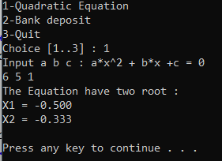

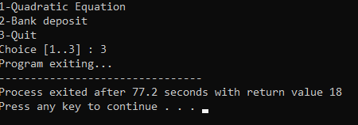

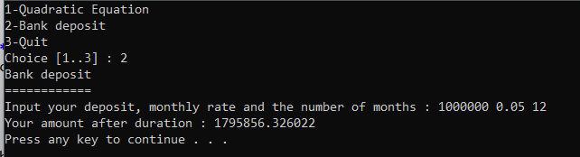

Related files can be found at: [Workshop 5 PRF192](https://fptuniversity-my.sharepoint.com/:f:/g/personal/tinnmbse170134_fpt_edu_vn/EgTbiyZWuFpCs--1HcV-xf8BgXbwFOsMeMob9eu5LRAc5w?e=h6dP62)